**Analogy**

* When an electric appliance needs power, we plug it in into socket
* Electricity is readily available in our home but actually generated over power stations
* We pay the electricity bill for whatever we have used because electricity is metered
* If we apply the same analogy to software/information technology services, this is what cloud exactly does.

**Pictorial Representation**

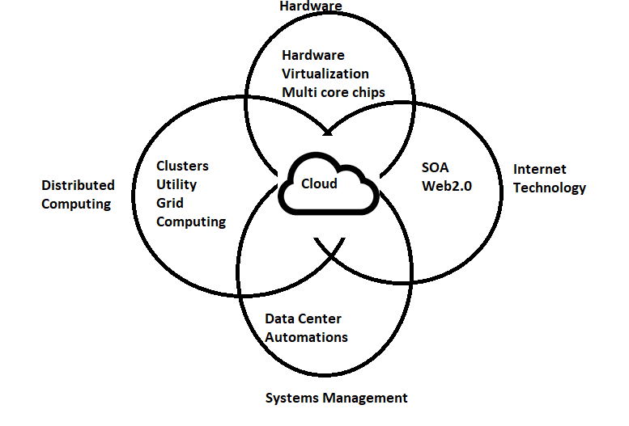

The NIST Definition of Cloud Computing

Cloud computing is a model for enabling ubiquitous, convenient, on-demand network access to a shared pool of configurable computing resources (e.g., networks, servers, storage, applications, and services) that can be rapidly provisioned and released with minimal management effort or service provider interaction. This cloud model is composed of five essential characteristics, three service models, and four deployments

**Experiment: We are starting a new project for airline reservations**

* Sample architecture will be as shown below 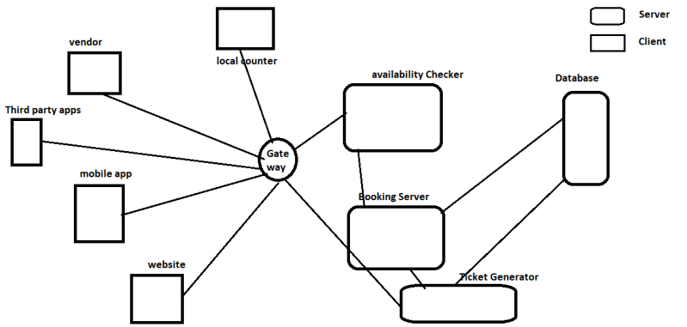
* Number of Server required to run this architecture at a bare minimum are 5
  + Availability Checker
  + Booking Server
  + Ticket Generator
  + Database
  + Gateway
* Where will these servers be located physically?
  + On-Premises Datacentre
* What will you do if Database crashed?

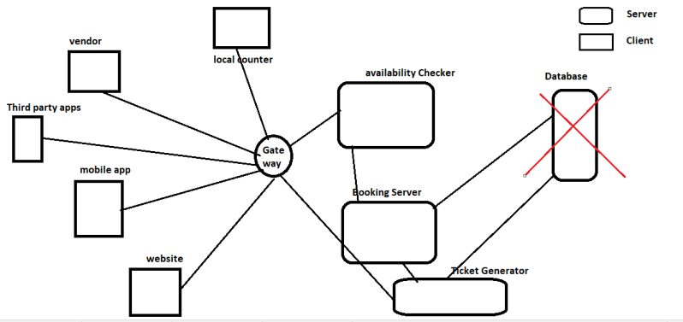

* + If the database is crashed whole application will be down
  + To resolve this, we will add a secondary database which has data in sync with primary database
  + Now even if primary db fails we can still run the show with secondary db

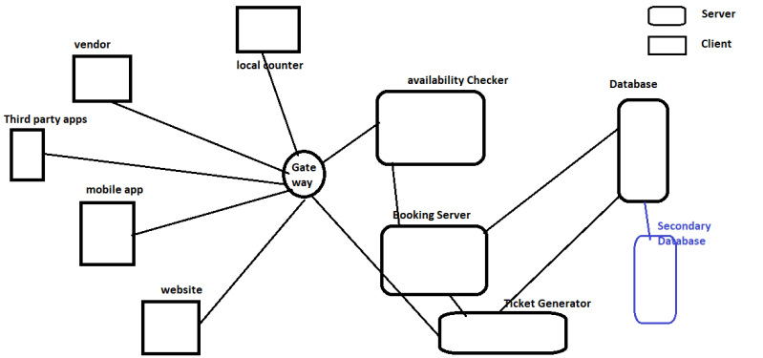

* What will happen if your datacentre has caught fire?
  + This is Disaster and we need to have disaster recovery plan
  + Let’s go with two datacentres in two locations of our enterprise

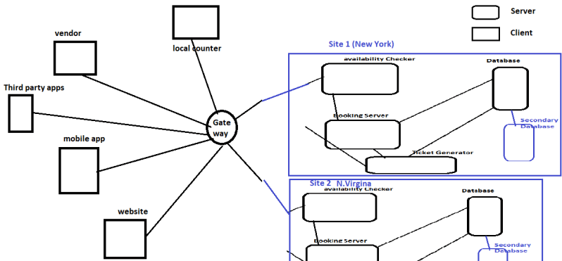

* + Pros: Effective for Disaster
  + Cons: Costly and requires decent connectivity between two sites
  + Let’s go with only storing the backup in other site

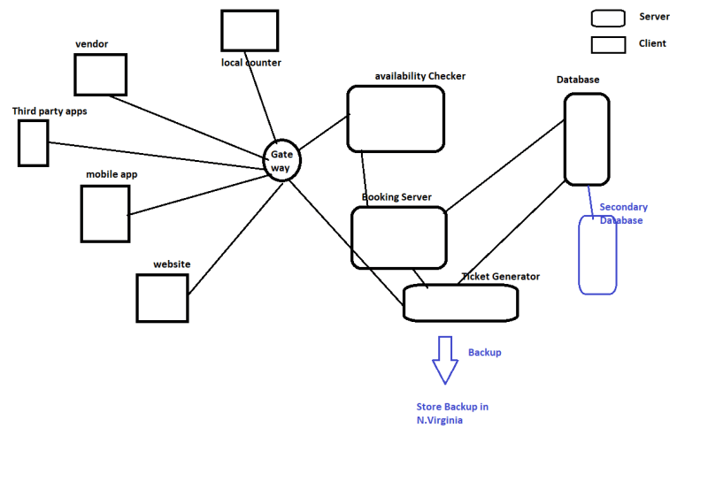

* + Pros: Easy to implement
  + Cons: In Case of disaster, this approach takes lot of time to bring back application online
* What will happen if the users to your application grow rapidly only during holiday season.